Distributed and Mobile Systems

Assignment 1 Part 2

Zeting Luo 16938158

Submit date: 24/May/2019 5:00 PM

Contents

0. Project requirement 2

1. Lab 6 Guess number game 2

2. Laboratory 7 Exercise 6 5

3. Laboratory 8 Exercises 3 8

# Project requirement

* JDK and JRE to support Android Studio
* Android Studio 3.3 or higher
* (optional) a android phone with android version 8.0 or higher

# Lab 6 Guess number game

* 1. Unzip the [COMP713-Assign1Pt2-16938158.zip] file
  2. 3 .zip files and 1 .pdf file should be in the unzip folder
  3. Unzip the .zip files, and make sure your file structure like this
     1. [COMP713-Assign1Pt2-16938158]  
        |-- [Lab*E*]  
        |------[.gradle]  
        |------[.idea]  
        |------[app]  
        |------(other files)
  4. Now you should have 3 project folders like photo shown down
     1. 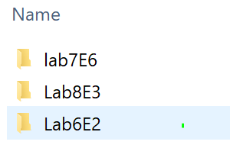
  5. Open Android studio, and select open project  
     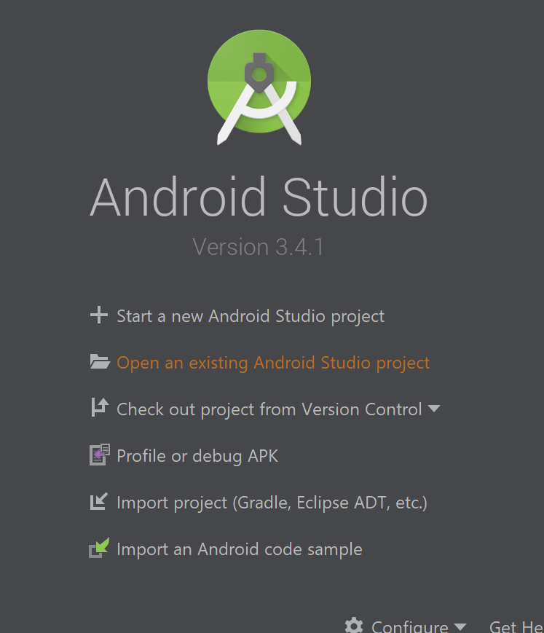
  6. Find the Lab6E2 project and open it  
     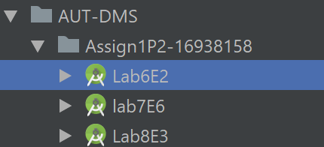
  7. Wait for android studio finish indexing file
     1. Error like this may come out but it is ok, do not affect the project in any way  
        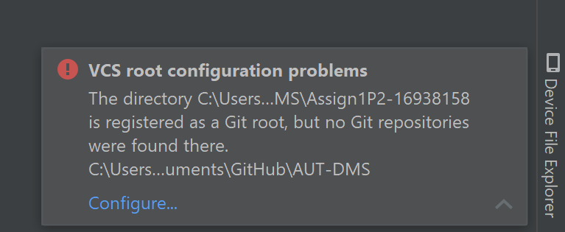
  8. After project files finish indexing, you can click the Run button on the top  
     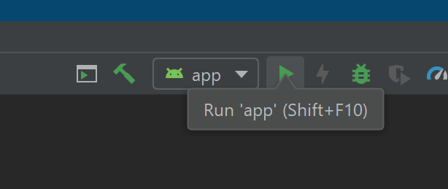
  9. Run the project on your phone or an android virtual device   
     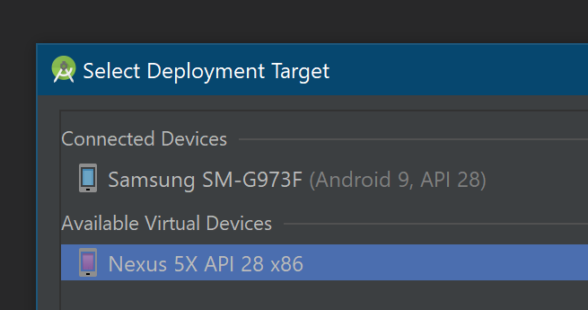
     1. In case you want to install the project and run it on your phone, a .apk file is provided and located in [Lab6E2] folder  
        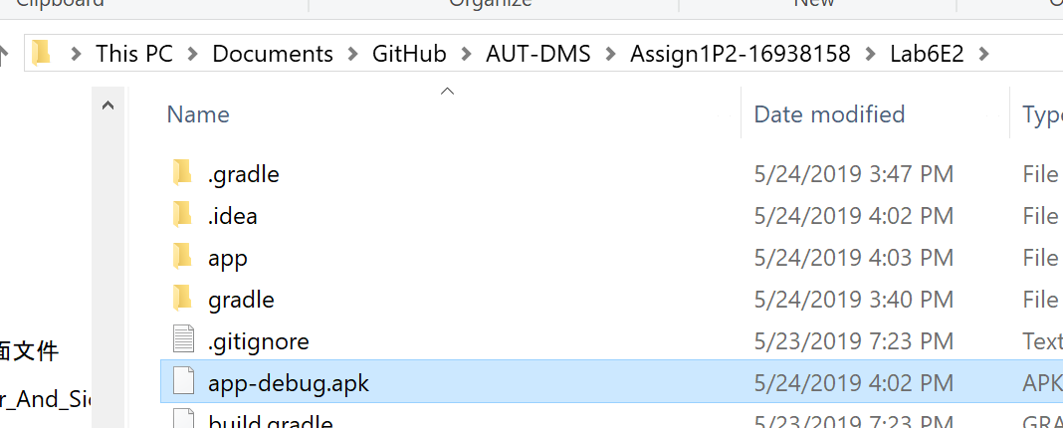
  10. Project should open like this  
      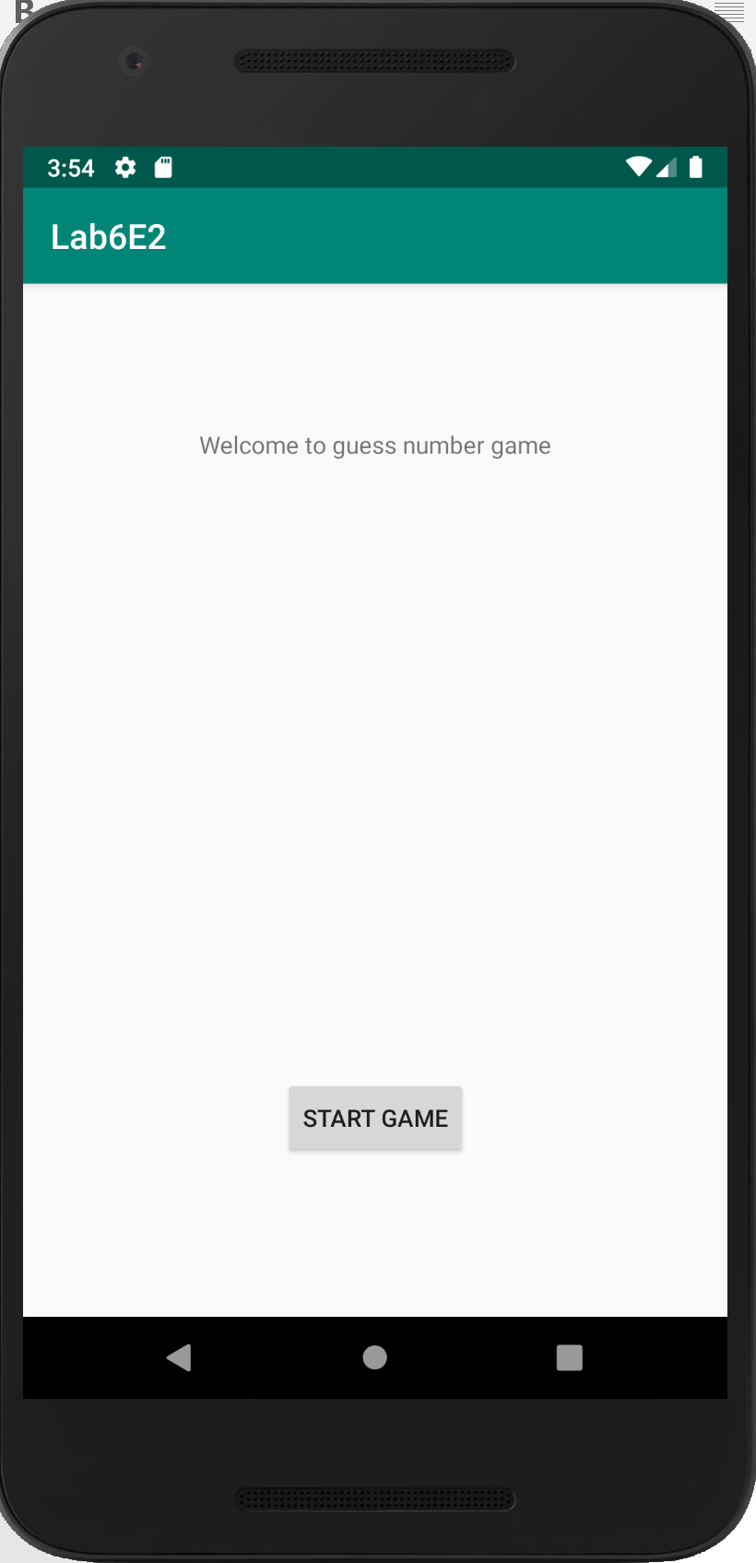
  11. Click the [START GAME] button for start the guess number game
  12. Follow the instruction in the game  
      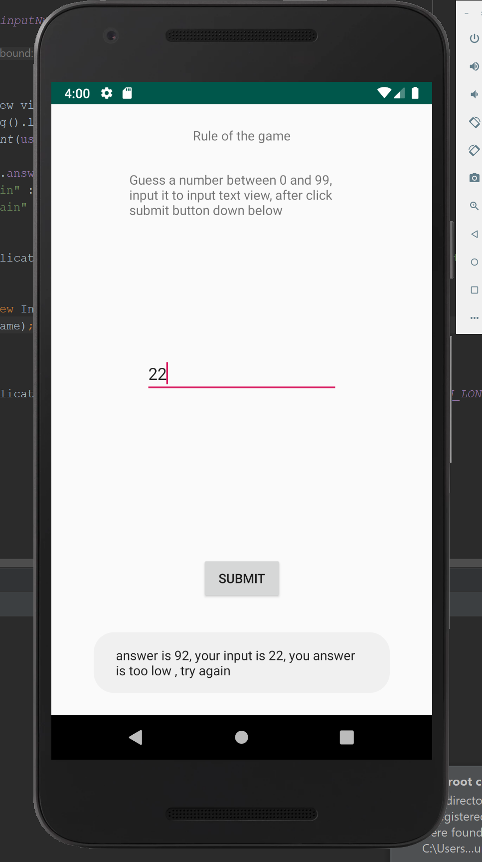

# Laboratory 7 Exercise 6

* 1. You should already have the project unzip
     1. If not, please follow instruction 1.1 to 1.3
  2. Open the project [Lab7E6] in android studio  
     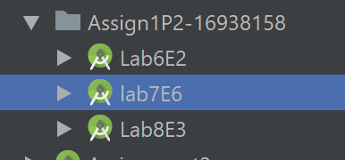
  3. Wait for files finish indexing
  4. After project files finish indexing, you can click the Run button on the top  
     
  5. Run the project on your phone or an android virtual device   
     
     1. In case you want to install the project and run it on your phone, a .apk file is provided and located in [Lab7E6] folder

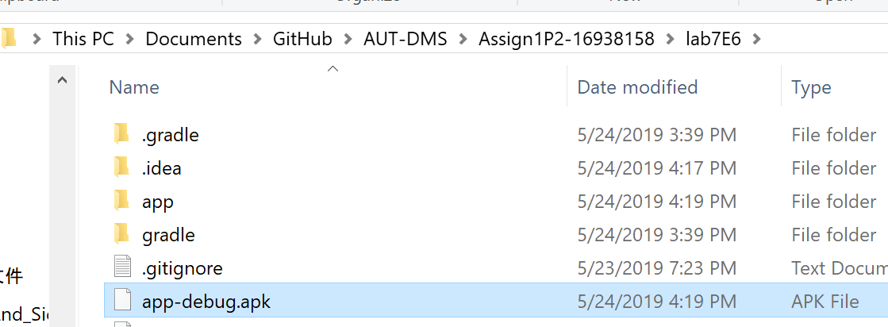

* 1. You should see an interface like photo shown below

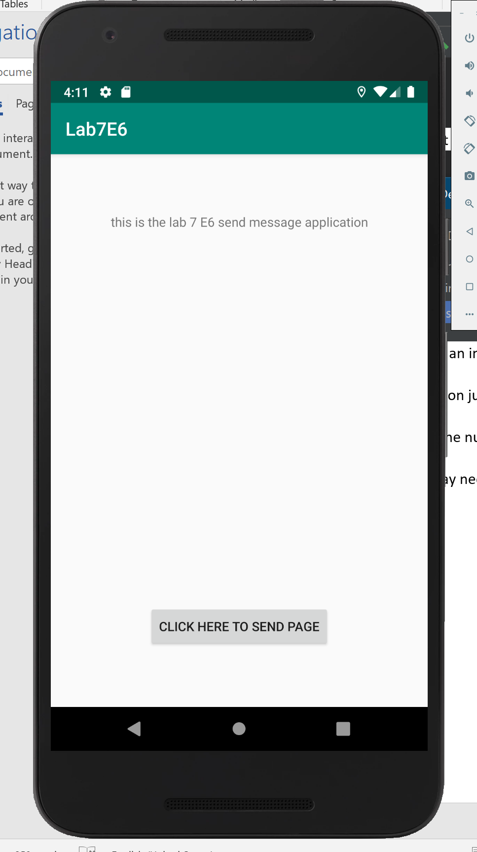

* 1. Click the [CLICK HERE TO SEND PAGE] button jump to the send message page
  2. Input your phone number and message   
     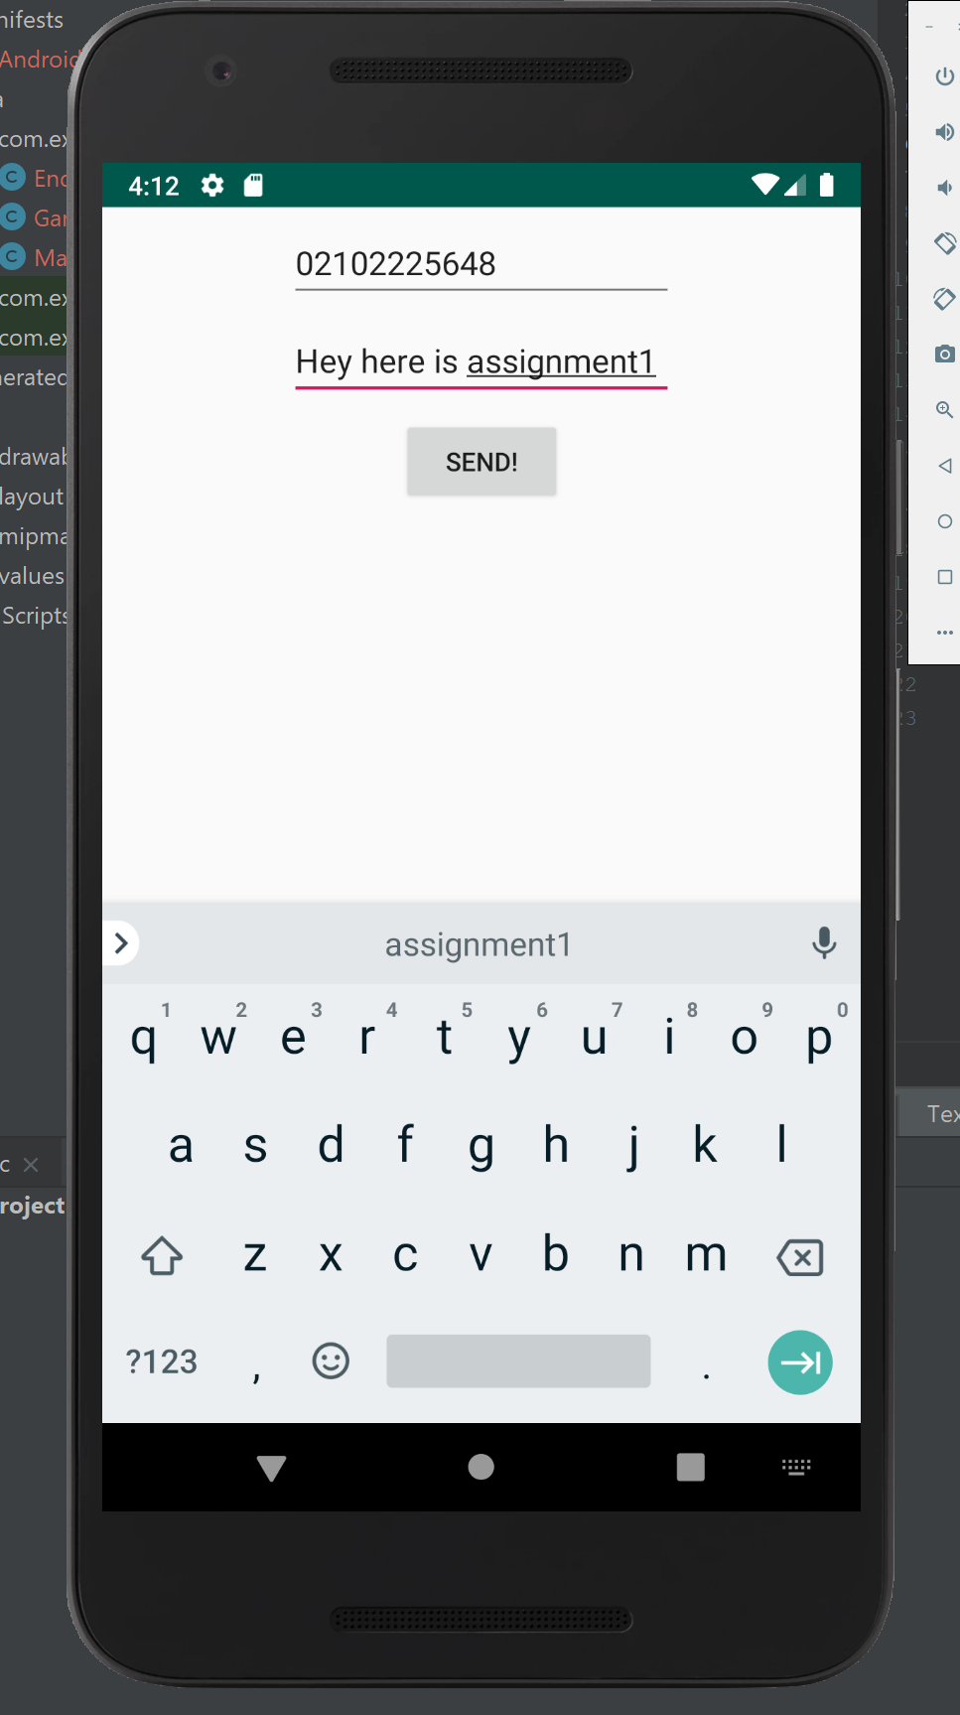
     1. You may need to give permission to the application to send the message  
        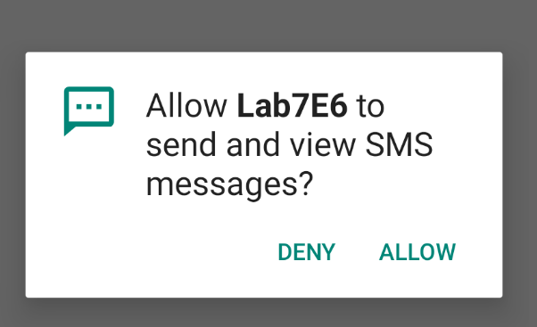
  3. Click the send button to send out the message  
     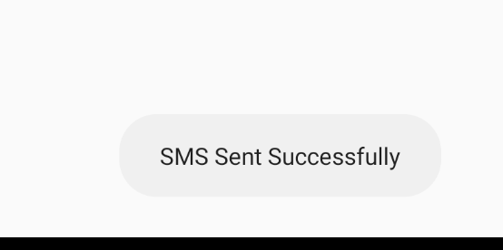

# Laboratory 8 Exercises 3

* 1. You should already have the project unzip
     1. If not, please follow instruction 1.1 to 1.3
  2. Open the project [Lab8E3] in android studio  
     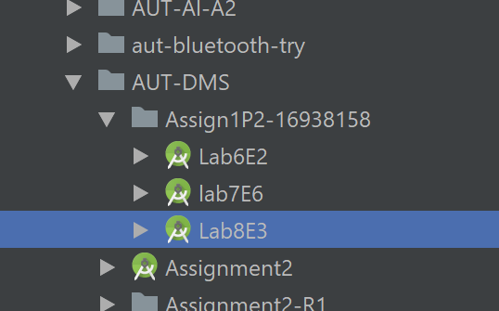
  3. Wait for files finish indexing
  4. After project files finish indexing, you can click the Run button on the top  
     
  5. Run the project on your phone or an android virtual device   
     
     1. In case you want to install the project and run it on your phone, a .apk file is provided and located in [Lab8E3] folder  
        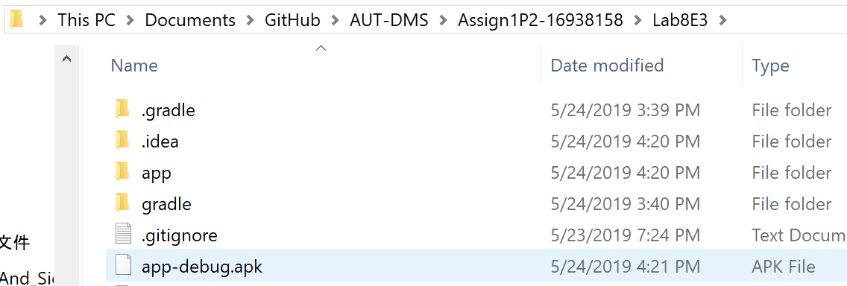
  6. You should see a interface like the photo shown below  
     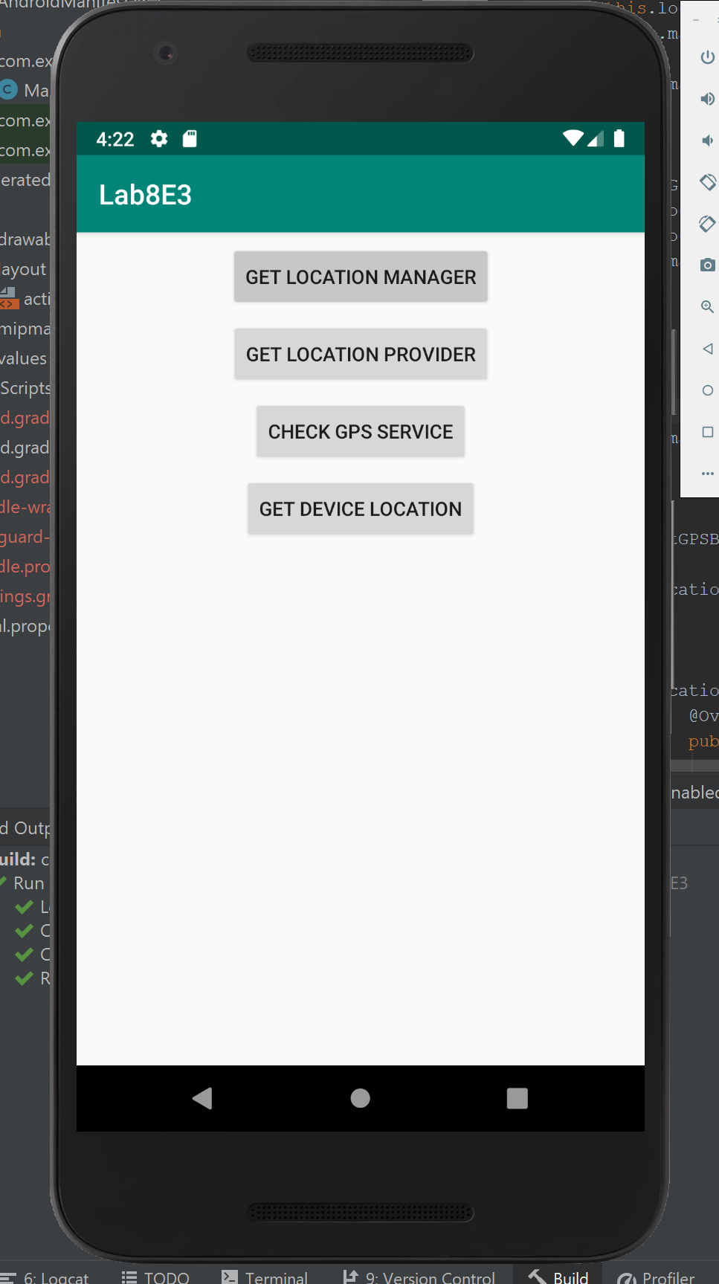
  7. Click the button one by one, information will show as Toast message  
     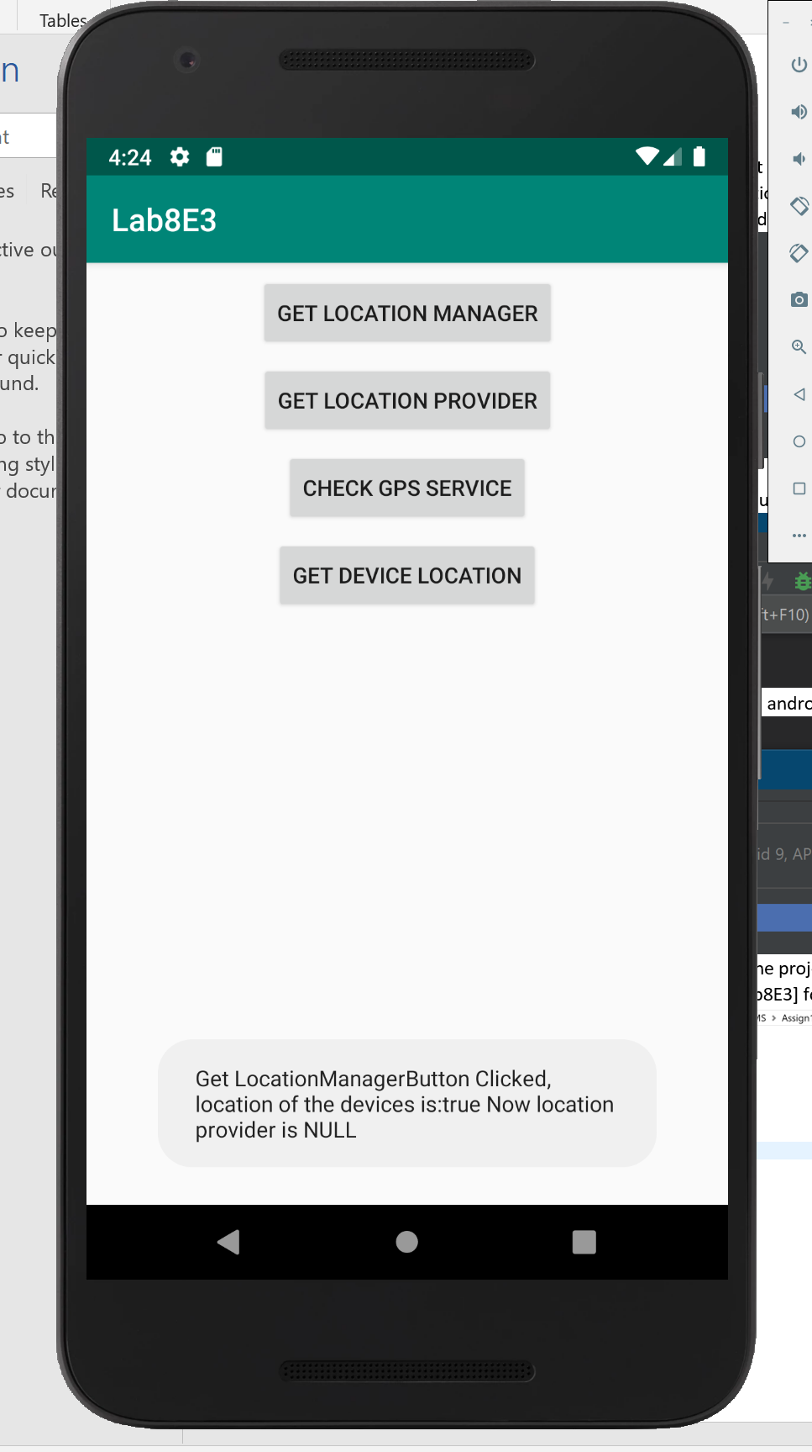
     1. You may need give permission in order to get the location of the devices (permission check will be trigger by the first time click the [GET LOCATION MANAGER] button  
        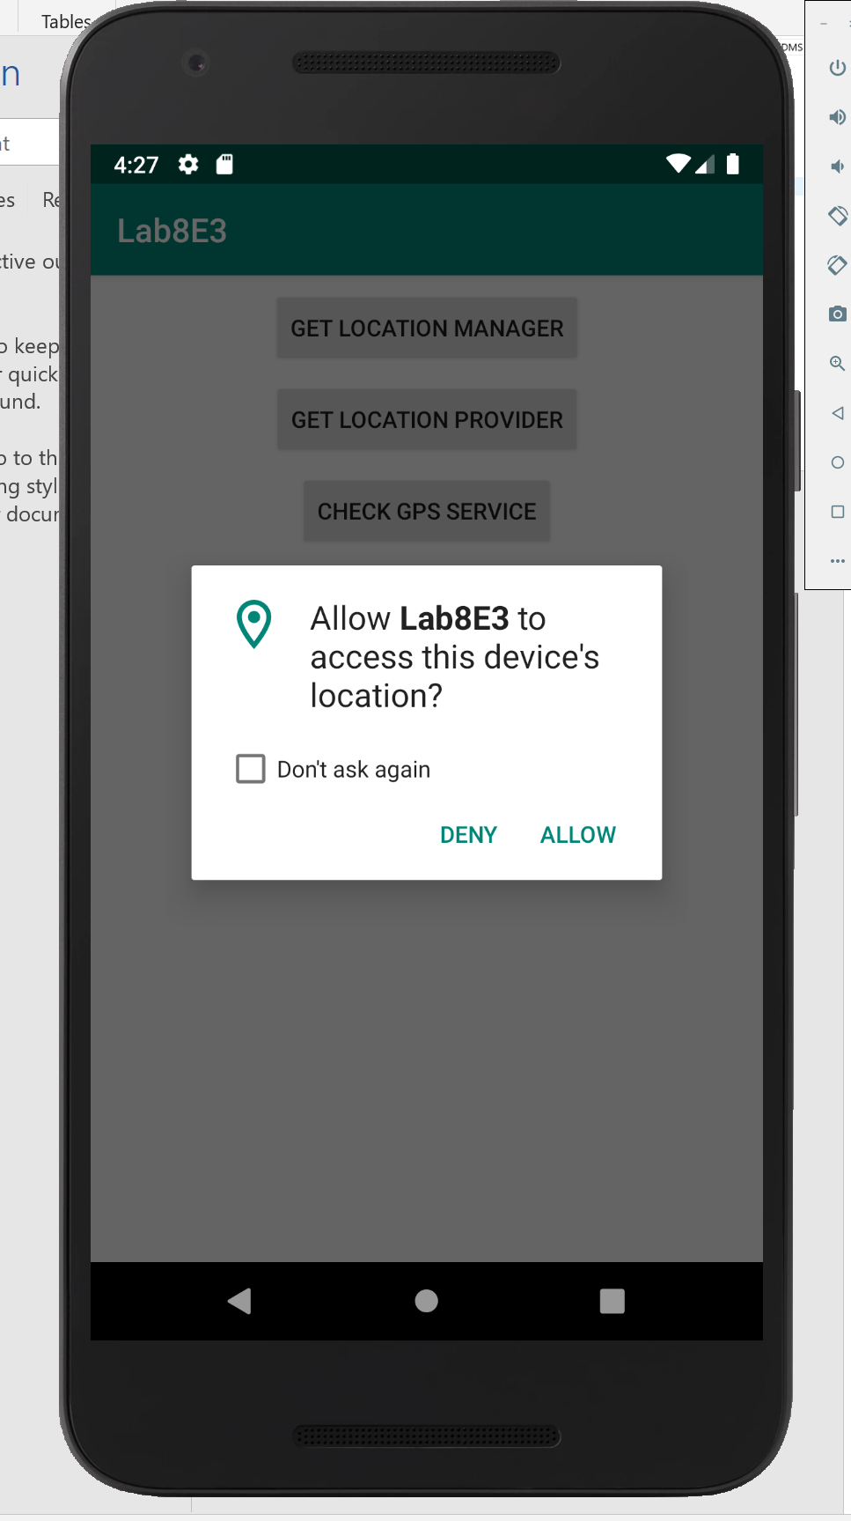
        1. After you give the permission, you should click the [GET LOCATION MANAGER] button again
     2. Usually, when you click the [GET DEVICES LOCATION] button, devices location should show up like the photo shown below, but if you run the application in a physical android device, it is a chance that your location having a very weak GPS signal (e.g. in WA building level 3). This will make the application not able to show your location, so you may need to go out door to test this project  
        